**1. Docker Architecture:**

Docker follows a **client-server architecture**, which includes the following components:

* **Docker Client:**  
  The interface through which users interact with Docker (e.g., CLI commands like docker run, docker build).
* **Docker Daemon (dockerd):**  
  The server running in the background that manages Docker objects like images, containers, networks, and volumes.
* **Docker Images:**  
  Read-only templates used to create containers. Each image is built from a Dockerfile.
* **Docker Containers:**  
  Running instances of Docker images that package the application and its dependencies.
* **Docker Registry:**  
  A repository (like Docker Hub) that stores Docker images.  
  Users can **pull** images from and **push** images to the registry.

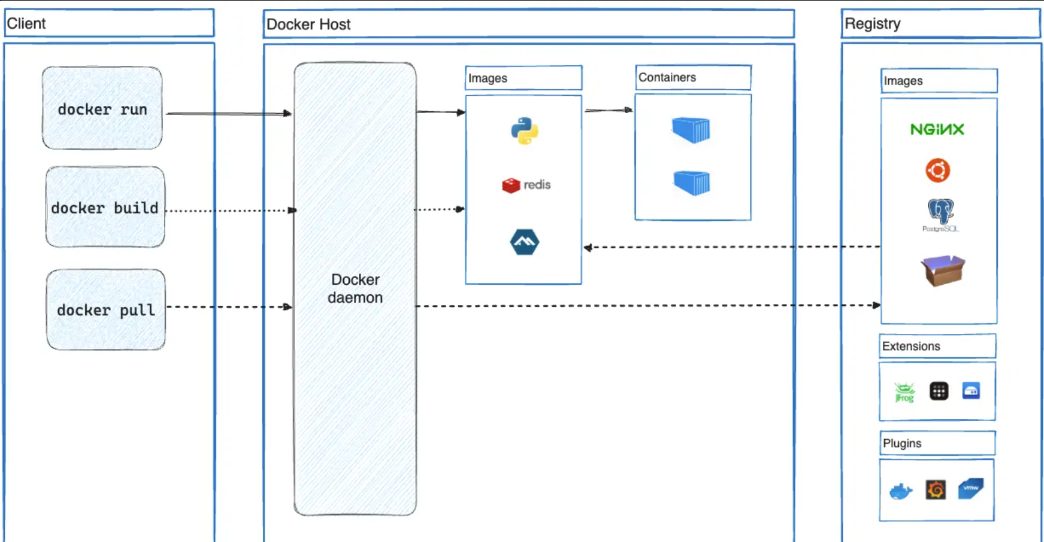

2**. Installation Steps**

# Update packages

sudo apt update

# Install Docker

sudo apt install docker.io -y

# Start and enable Docker service

sudo systemctl start docker

sudo systemctl enable docker

# Verify installation

docker –version

3. Docker Commands to Manage Images and Containers:

# Pull an image from Docker Hub

docker pull ubuntu

# List available images

docker images

# Remove an image

docker rmi <image_id>

**Docker Container Life Cycle:**

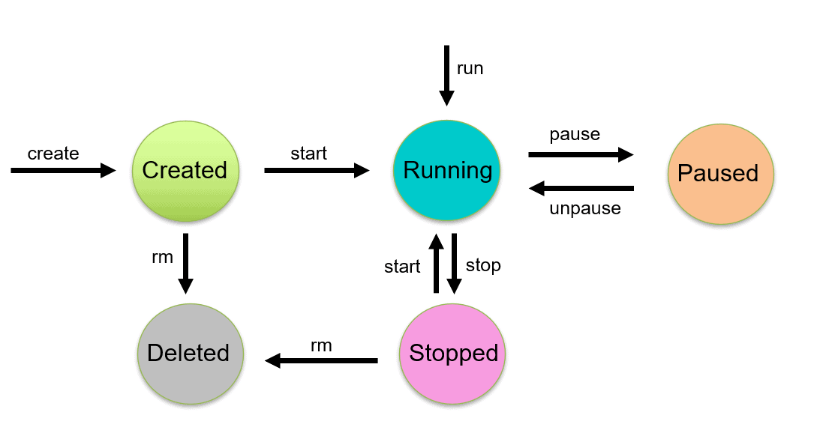

EXPERIMENT-7

eval $(minikube docker-env -u) if you did 8 and then again want to do 7

mkdir k8s-demo-app

cd k8s-demo-app

vim app.js

const express = require("express");

const app = express();

const port = 3000;

app.get("/", (req, res) => {

res.send("Hello from Kubernetes App!");

});

app.listen(port, () => {

console.log(App running on port ${port});

});

Vim package.json

{

"name": "k8s-demo-app",

"version": "1.0.0",

"main": "app.js",

"scripts": {

"start": "node app.js"

},

"dependencies": {

"express": "^4.18.2"

}

}

Vim dockerfile

FROM node:18-alpine

WORKDIR /app

COPY package*.json ./

RUN npm install

COPY . .

EXPOSE 3000

CMD ["npm", "start"]

docker build -t k8s-demo-app:v1 --no-cache .

docker run -p 3000:3000 k8:v1

docker login

8th

cd ~/flask-app

vim app.py

from flask import Flask

app = Flask(__name__)

@app.route('/')

def home():

return "Hello from Flask App running on Kubernetes! 🚀"

if __name__ == '__main__':

app.run(host='0.0.0.0', port=5000)

vim requirements.txt

Flask==2.2.5

Vim dockerfile

FROM python:3.9-slim

WORKDIR /app

COPY . .

RUN pip install -r requirements.txt

EXPOSE 5000

CMD ["python", "app.py"]

minikube start

eval $(minikube docker-env)

docker build -t flask-k8s-app:1.0 .

vim deployment.yaml

apiVersion: apps/v1

kind: Deployment

metadata:

name: flask-deployment

spec:

replicas: 2

selector:

matchLabels:

app: flask-app

template:

metadata:

labels:

app: flask-app

spec:

containers:

- name: flask-app

image: flask-k8s-app:1.0 # Local image in Minikube

imagePullPolicy: Never # <--- This line is REQUIRED for local images

ports:

- containerPort: 5000

Vim service.yaml

apiVersion: v1

kind: Service

metadata:

name: flask-service

spec:

type: NodePort

selector:

app: flask-app

ports:

- protocol: TCP

port: 5000

targetPort: 5000

nodePort: 31001

kubectl apply -f deployment.yaml

kubectl apply -f service.yaml

kubectl get pods

minikube service flask-service

9EXPERIMENT

wget <https://apt.puppet.com/puppet-release-bionic.deb>

sudo dpkg -i puppet-release-bionic.deb

sudo apt update

sudo apt install puppetserver -y

sudo systemctl start puppetserver

sudo systemctl enable puppetserver

sudo nano /etc/puppetlabs/puppet/puppet.conf

put the below on in it

[agent]

server = daivik

environment = production

runinterval = 30m

ctrl+x , Y, enter

# Start Puppet Server

sudo systemctl start puppetserver

sudo systemctl enable puppetserver

# Start Puppet Agent

sudo systemctl start puppet

sudo systemctl enable puppet

sudo /opt/puppetlabs/bin/puppet agent --test

10

puppet –version

mkdir -p ~/puppet-demo/modules/webserver/{manifests,lib/puppet/functions/webserver}

nano ~/puppet-demo/modules/webserver/manifests/init.pp

class webserver {

package { 'apache2':

ensure => installed,

}

service { 'apache2':

ensure => running,

enable => true,

}

file { '/var/www/html/index.html':

ensure => file,

content => "<h1>Hello from Puppet Webserver!</h1>",

}

# Call custom function (Puppet 8)

$message = webserver::greet()

notify { $message: }

}

nano ~/puppet-demo/modules/webserver/lib/puppet/functions/webserver/greet.rb

Puppet::Functions.create_function(:'webserver::greet') do

def greet()

"Webserver setup done!"

end

end

nano ~/puppet-demo/site.pp

include webserver

sudo /opt/puppetlabs/bin/puppet apply /home/daivik/puppet-demo/site.pp --modulepath=/home/daivik/puppet-demo/modules --debug